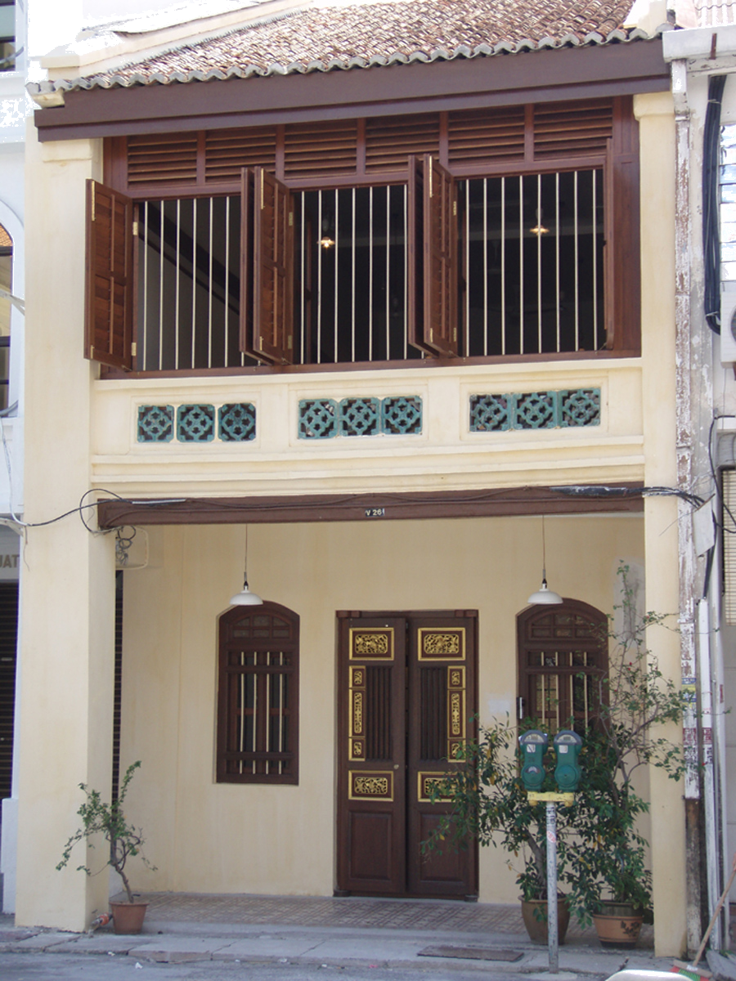 | THE PENANG HERITAGE TRUST  26 Church Street, 10200 Penang Malaysia  Tel: 04-2642631 E-mail: info@pht.org.my  FORM FOR NOMINATION OF CANDIDATES FOR AWARD OF  ‘PENANG HERITAGE TRUST LIVING HERITAGE TREASURES OF PENANG’  Sponsored by 7-terraces

Living Heritage Treasures are persons who embody or who have, in the highest degree, the skills and techniques necessary for the production of certain aspects of our social, cultural and religious life in Penang, the life of our cultural communities and the continued existence of our cultural heritage. These aspects of cultural life may be exceptional to Penang and they may be experiencing scarcity, vulnerability or loss of significance.
Through time, dedication, practice and persistence, these persons may also have advanced, promoted or preserved skills and techniques considered traditional and core to our Penang cultural heritage. They may come from ANY of the following categories (individuals or collective groups):

- Applied Skills & Arts – e.g. visual arts - artists, carvers, weavers, artisans; e.g. culinary skills – production of famous Penang foods; e.g. martial arts - masters in traditional self defence, in traditional medicine, bone-setting etc
- Performing Arts – musicians, performers, dancers – e.g. bangsawan, boria, teochew opera
- Literary Arts - poets, playwrights, novelists, journalists
- Holders / Performers of Cultural rites / Customs – bomohs, herbalists & spiritual healers, conductors of rites de passage etc

The ‘Living Penang Heritage Treasure’ should be a leading proponent of his/her particular skill and should possess or exhibit some, if not all of the following :

- an exceptional standard or degree of skill
- a dedication and commitment to the practice of the particular cultural heritage
- a persistent promotion of the skills, processes or techniques
- an ability to either maintain the original authentic form of the cultural product or to enhance and develop it in a process of evolution
- an ability and an interest to pass on the skills or techniques to trainees
- an extensive and prolonged involvement – a criterion of age

AWARDEES WILL RECEIVE : A PLAQUE, A CERTIFICATE & RM 2,000 PER YEAR
THERE ARE ONLY 8 AWARDEES AT ANY ONE TIME

ENTRY MATERIALS TO BE SUBMITTED

- Entry Form | Each entry must be submitted with an official entry form together with the following materials.
- Photographs | A minimum of 3 different photos of the NOMINEE must be included with each entry. All photographs must be clearly labelled.
- Supporting Materials | Extra photographs of work/ skills/ products, documentary materials, samples, newspaper cutting and so on may be included. Please only send material of which you have copies, not original or unique materials of high value.

ENTRY FORM

- NAME OF NOMINEE: ……………………………………………………………………………... M / F

- ADDRESS:……………………………………………………………..…………………………………

…………………………………………………………………………………………………………….

- NOMINEE CONTACT NUMBER

(Home/ office) …………………………………. (H/P) …………………………….……………….

- DATE OF BIRTH OF NOMINEE:…………………………..…… I.C.NO……………………….……

- CULTURAL HERITAGE / SKILL POSSESSED ……………………………………………………………………………………………………………..

……………………………………………………………………………………………………………..

……………………………………………………………………………………………………………..

- NUMBER OF YEARS IN PRACTICE…….………………………………………………………………

7. REASONS FOR NOMINATION
I believe that ………………………..…………. should be considered a candidate for the Living Heritage Treasure of Penang Awards 2021 because

……………………………………………………………………………………………………………

……………………………………………………………………………………………………………

……………………………………………………………………………………………………………

……………………………………………………………………………………………………………

……………………………………………………………………………………………………………

……………………………………………………………………………………………………………

(Extra information may be included that will assist judges in making their assessment)

8. NAME OF PERSON NOMINATING……………………………………..

9. RELATIONSHIP TO NOMINEE ……………………………………….

- CONTACT NOS.: TEL: ……………………………….. FAX:………………………………… …….

HP : …………………………………………………. E-MAIL: …………………………………...

TO BE FILLED IN BY THE NOMINEE

I agree to be nominated for the Living Heritage Treasures of Penang Award 2021.

………………………………….. …………………
Signature & Name: Date:

DUTIES OF THE AWARDEES

If I win this award I agree to:

- Allow perpetuation & development of the skills & techniques
- Allow documentation / recording to be conducted for archival purposes by appropriate bodies. I understand that this documentation will not be used for any commercial purpose without my knowledge and agreement
- The transmission of skills, practices, techniques wherever I feel it is possible, through a prescribed training system so that the future of this cultural heritage will not be lost
- Allow the non-profit charitable organisation of the Penang Heritage Trust to use my name when promoting the Living Heritage Treasures of Penang Award

